

**2018 Orthodox Youth Conference at Mountain View**

Encouraged by the warm support and hierarchal blessing of our Archbishop Andronik, the 2018 Orthodox Youth Conference will be hosted again this year at Mountain View. The program is scheduled to begin on Saturday, February 17th at 9:00 AM and conclude on Monday February 19that 7:00 PM.

The participants can arrive on Friday the 16th after 7:00PM and must leave by Tuesday February 21st at 11:00AM. The Conference will be held in Mountain View Russian Orthodox and Cultural Center, 2781 State Route 145, Middleburgh NY, 12122 (2-1/2 hour drive North from NYC).

*What is the goal of the Youth Conference?*

The benefit of our Youth Conference is the opportunity to ask, and then find answers to some common questions and issues from an Orthodox perspective. To discover together with our young worshippers the meaning of our traditions, how they can be applied to modern problems, and the reason why we should follow the teachings of our Church. The strong bonds which develop between our participants usually support a true and honest discussion. We share the intimacy of prayer, spend several days in close proximity, and sing and laugh while participating in the many activities. The conference is an excellent time to open our hearts that the Lord hear us and grace our minds.

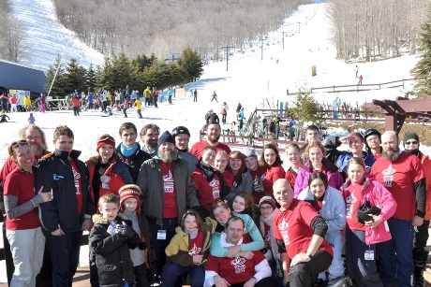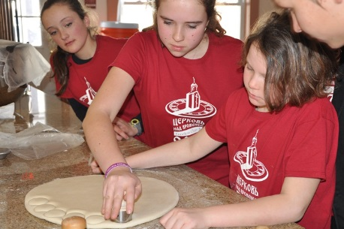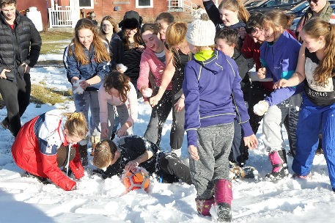

*Who can participate in the Conference?*

Any Orthodox person from age 14 and up may register. Space is limited and the number of participants is restricted.

*In what language will the Conference will be held in?*

Both Russian and English will be the languages used. Based on previous experience, the languages are mixed and there are people translating at all times. Some lectures and activities will be held in English and others in Russian.

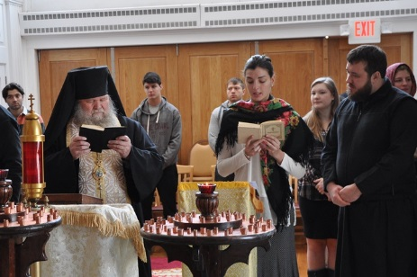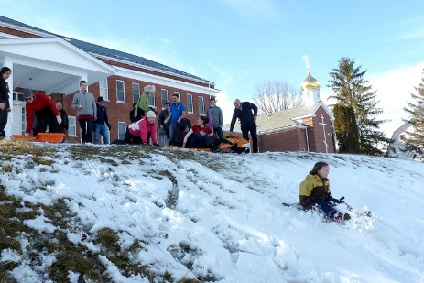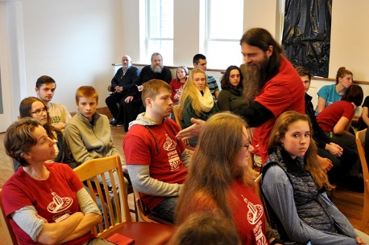

*What if I want to stay only for a portion of the conference?*

The priority will be given to persons who intend to stay from Saturday morning through Monday afternoon. If you cannot attend the entire time, complete the form and apply nonetheless, and the organizers will let you know whether this will be feasible or not.

*What is the cost of the conference?*

The cost for the entire conference, including the ski trip on Monday, is $250 per person. All meals are included in this price.

*What should I leave at home?*

Please do not bring video games, I-pads, computers, smart phones and any other electronics. Leave at home any kind of items that can disturb the conference. The organizers have the right to confiscate any of the above mentioned items for the duration of the conference. If you will need to make a call, you may do so during the “free time”. Leave your “attitude” at home. Everybody who attends the conference hopes to have a great and healthy time together. No alcohol, drugs or smoking are permitted on the premises.

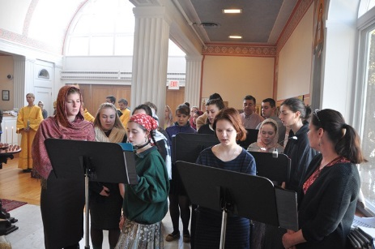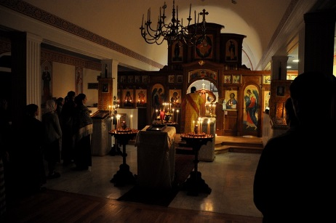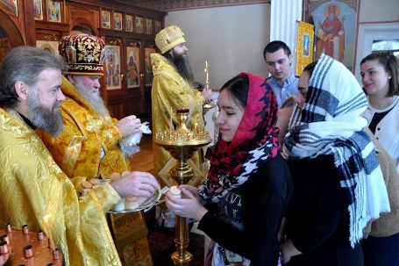

*What should I bring?*

Middleburgh is usually ten degrees colder that NYC, because of the winds and the fact that it is located at a higher elevation. Bring warm clothes, a sleeping bag, a pillow, a sleeping pad, and a towel. Bring a spare pair of shoes, and winter gear for the outdoor activities.

If you are interested, please complete the attached application and mail it to the address indicated on the form with your payment.

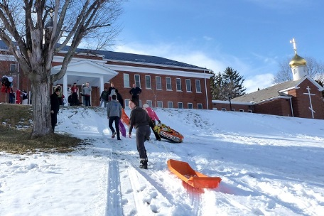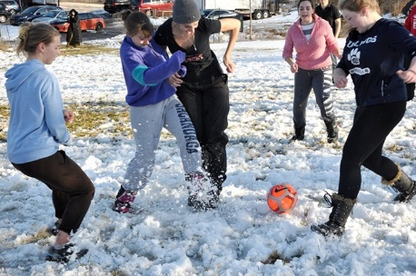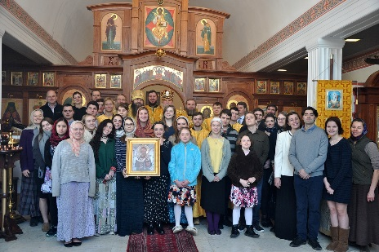

We look forward to welcoming you at Mountain View!

The 2018 Organizing Committee

Contact:

[MVROC2013@gmail.com](mailto:MVROC2013@gmail.com) or 914-523-0059